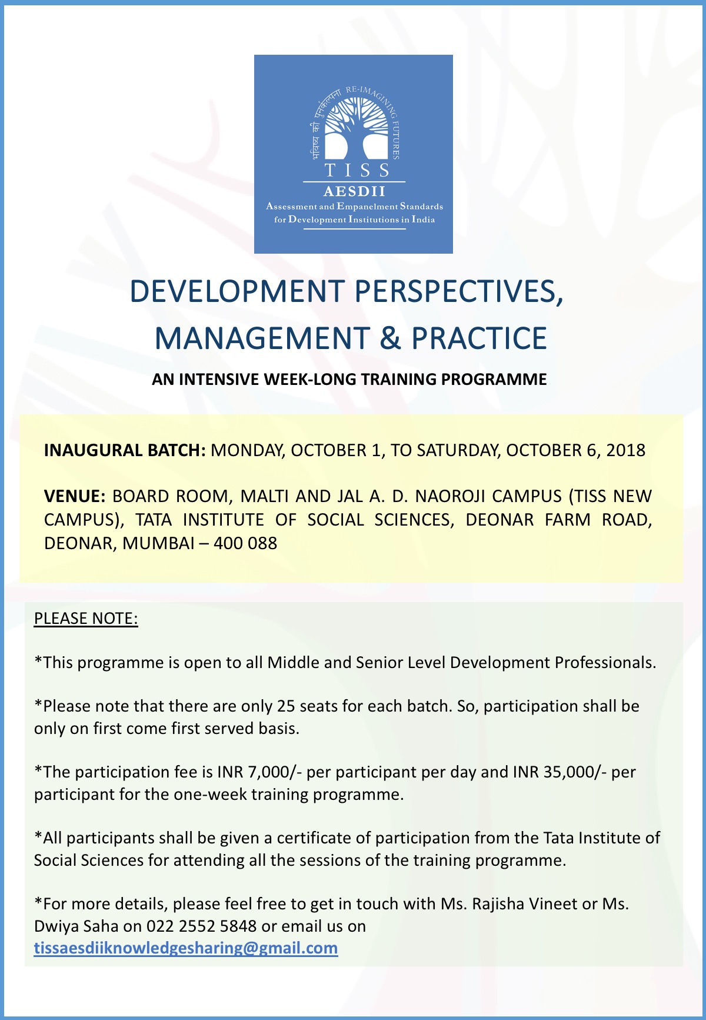

DAY 1: MONDAY, OCTOBER 1, 2018

Analytical and Conceptual Frameworks for Doing and Measuring Development
Time/Duration | Module | Faculty | Affiliation
10:00 am – 10:30 am  30 minutes | About TISS AESDII | rohan sarma | Senior Fellow and Head –  TISS AESDII,  Centre for Public Policy and Governance,  TISS
10:30 am – 12.00 pm  90 minutes | Contextualising Social Responsibilities of State, Corporations and Civil Society Actors Against the Backdrop of Development Challenges | Prof. S. Parasuraman | Former Director, TISS and Current Senior Fudan Fellow, Fudan University, Shanghai, China
12:00 pm – 01:30 pm  90 minutes | Sustainable Development:  Perspectives, Management and Practice | Prof. Amit Lahiri | Chief Sustainability Officer and Executive Director, CECRAS,  O.P. Jindal Global University
02:30 pm – 05:00 pm  150 minutes | Assessment of Developmental Needs:  Methodologies, Methods, Tools and Challenges | Prof. S. Sivaraju | Deputy Director,  Hyderabad Campus,  TISS

DAY 2: WEDNESDAY, OCTOBER 3, 2018

Fundamentals of Development Management
Time/Duration | Module | Faculty | Affiliation
10:00 am – 01:30 pm  210 minutes | Fundamentals of Monitoring, Evaluation and Developing Matrices for Social Impact | Prof. Bhaskar Mittra | Associate Director,  Tata-Cornell Institute For Agriculture and Nutrition
02:30 pm – 04:00 pm  90 minutes | Measuring Human Development: Perspectives, Planning and Practice | Dr. Sandhya Iyer | Chairperson,  Centre for Public Policy, Habitat and Human Development, School of Development Studies,  TISS
04:00 pm – 05:00 pm  60 minutes | Corporate Social Responsibility: Law, Project Management and Strategic Actions | Prof. Amit Lahiri | Chief Sustainability Officer and Executive Director, CECRAS,  O.P. Jindal Global University

DAY 3: THURSDAY, OCTOBER 4, 2018

Organizational Development and Leadership
Time/Duration | Module | Faculty | Affiliation
10:00 am – 12:00 pm  120 minutes | Organizational Learning, Development and Change | Prof. P. Vijayakumar | Chairperson,  Centre for Social and Organizational Leadership, TISS
12:00 pm – 01:30 pm  90 minutes | Transformational Leadership | Prof. Zubin Mulla | Professor,  School of Management and Labour Studies,  TISS
02:30 pm – 05:00 pm  150 minutes | Thinking Differently: Strategies for Organizational Thought, Leadership and Action | Prof. Sasmita Palo | Dean,  School of Management and Labour Studies,  TISS

DAY 4: FRIDAY, OCTOBER 5, 2018

Frameworks for Reporting and Disclosures
Time/Duration | Module | Faculty | Affiliation
10:00 am – 01:30 pm  210 minutes | The GRI (Global Reporting Framework) Framework for Accountability, Sustainability and Responsibility of Development Actor | Dr. Aditi Haldar | Director,  GRI Regional Hub,  South Asia
02:30 pm – 05:00 pm  150 minutes | Organizational Financial Management and Strategies for Good Governance and Fundraising | Lalit Sethi | Senior Chartered Accountant and Financial Consultant,  TISS AESDII,  TISS

DAY 5: SATURDAY, 6TH OCTOBER 2018

Building Partnerships
Time/Duration | Module | Faculty | Affiliation
10:00 am – 1:30 pm  210 minutes | Workshop on Building Effective Partnerships through Communication, Documentation and Story-telling | Ami Misra  Amita Parulkar | Programme Specialists,  TISS
02:30 pm – 03:30 pm  60 minutes | Workshop on Stakeholder and Resource Mapping | Ami Misra  Amita Parulkar | Programme Specialists,  TISS
03:30 pm – 05:00 pm  90 minutes | Building Partnerships through TISS AESDII initiatives | rohan sarma | Senior Fellow and Head –  TISS AESDII,  Centre for Public Policy and Governance,  TISS

The fine print

*This programme is open to all Middle and Senior Level Development Professionals.
*Please note that there are only 25 seats for each batch. So, participation shall be only on first come first served basis.
*All participants shall be given a certificate of participation from the Tata Institute of Social Sciences for attending all the sessions of the training programme.
*For more details, please feel free to get in touch with Ms. Rajisha Vineet or Ms. Dwiya Saha on
022 2552 5848 or email us on tissaesdiiknowledgesharing@gmail.com

Payment Information:

*The participation fee is INR 7,000/- per participant per day and INR 35,000/- per participant for the one-week training programme.
*Participants are requested to note that the above amount includes Breakfast, Lunch and three rounds of Tea/Coffee every day, Reference Materials, Institute Charges @ 10% and GST @ 18%.

A Demand Draft (DD) should be drawn in favour of:

TATA INSTITUTE OF SOCIAL SCIENCES, MUMBAI

Please make the payments on/ by September 25, 2018.
Please download the GST declaration on the following url – https://goo.gl/XF5Dzj
Please download the invoice requisition form on the following url – https://goo.gl/UQd5ue

The DD and GST declaration, invoice requisition form should be sent to the following address:
Ms. Rajisha Vineet Empanelment Coordinator (Administrative),Secretariat,
National CSR Hub, 10th floor, M.S. Gore Academic Building,
Tata Institute of Social Sciences (New Campus) Deonar,
Mumbai – 400088
Contact Number: 022-25525848

