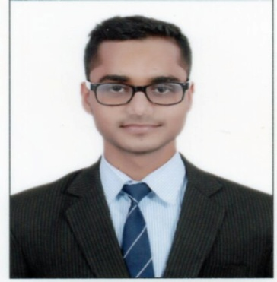**Nitin Kumar**

Management Trainee

Educate Girls

**Contact**: +91 8506853209

**Email & Skype**: [knitin584@gmail.com](mailto:knitin584@gmail.com)

**Career Objective:**  Quest to work in a professional atmosphere, which will help me to impart knowledge about the social Environment by virtue of my sincerity and dedication. I intend to contribute positively towards the growth and Prosperity.

**Educational Qualification:**

|  |  |  |
| --- | --- | --- |
| **Degree** | **University/Institution** | **Year** |
| Post Graduate Diploma in Management (Rural Management) | IRM, Jaipur- Rajasthan | 2015-17 |
| Bachelor of Science (Computer Science) | Vardhman College. MJP Rohilkhand University, Bijnor- Uttar Pradesh | 2011-14 |
| Diploma in Computer (Course on Computer Concept) | Kites Computer Center, Bijnor-Uttar Pradesh | 2016 |

**Internships**

|  |  |  |  |  |
| --- | --- | --- | --- | --- |
| **Sr. No.** | **Organization** | **Project Title** | **Duration** | **Place** |
| 1 | Abhinav Farmers Club | A Study on the effect of Abhinav farmers club on the livelihood of the SHG members with special reference to Rihe village in Pune district | 50 Days | Pune, Maharashtra |
| 2 | DRISHTEE Foundation | A Study on Handmade Products for Livelihood of Rural Women in Lucknow | 15 Days | Noida, Uttar Pradesh |
| 3 | Abhinav Prapti Farmers Club | Green House and Floriculture Training at Abhinav Prapti Farmers Club, Baramati, (Pune) | 10 Days | Pune, Maharashtra |

**Experience**

|  |  |  |  |  |
| --- | --- | --- | --- | --- |
| **Sr. No.** | **Organization** | **Designation** | **Duration** | **Place** |
| 1 | Foundation to Educate Girls Globally | Management Trainee  Program | Jan’17 to Apr’18 | Jhabua, Madhya Pradesh |

**TECHNICAL SKILLS**

* Basic knowledge of computer (MS Word, Excel, Power point, Internet)
* Knowledge of Computer typing (English)
* Diploma in Computer (Course on Computer Concept)

**PERSONALITY TRAITS**

* Punctuality
* Hard Working and Honest
* Positive Thinking
* Take Initiatives
* Helpful Nature and Soft Spoken

**EXTRA-CURRICULAR ACTIVITIES & ACHIEVEMENTS**

* Field work of Feasibility Study for the New Proposed Sales Outlets of Khadi and Village Industries Commission (KVIC) under MSME 2016-17 in Jaipur
* National Stock Exchange Certification in Financial Management Module (Commercial Banking in India)

**PERSONAL DETAILS**

Father’s name : Mr. Gajendra Kumar

Date of Birth : 09/12/1994

Gender : Male

Language known : English, Hindi

Nationality : Indian

Hobbies : Reading, Listening Music

**DECLARATION**

I, hereby declare that all the information mentioned above is true to the best of my knowledge.

**Date: 18/07/2018** Nitin Kumar