# Monalisa Barman| 09.03.1990 /27yrs

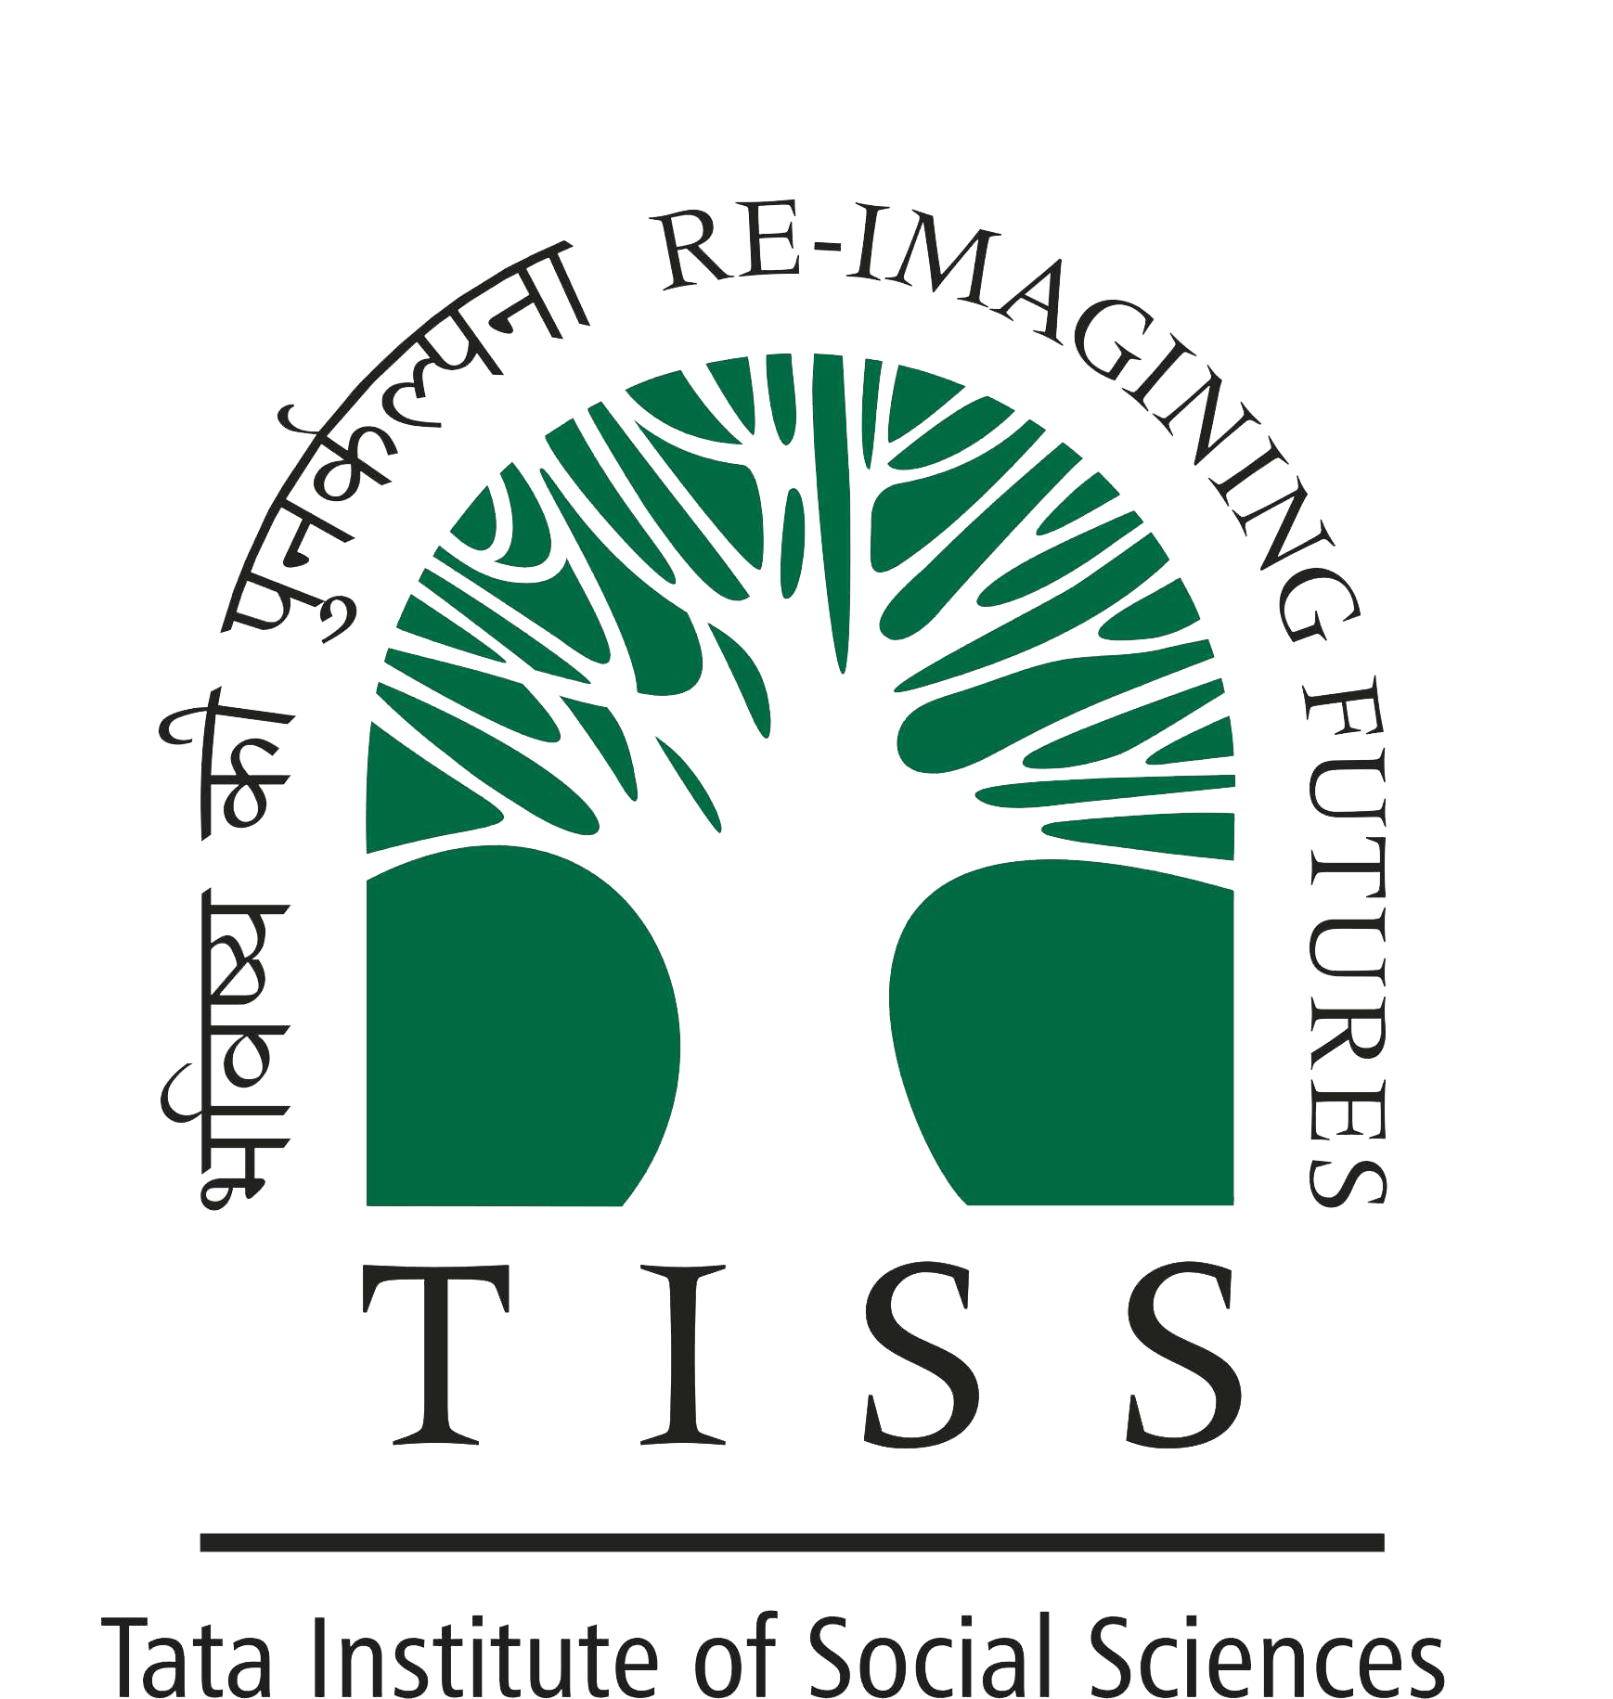

## Phone: +917045717517

Email: [monalisa.liz.barman1@gmail.com/monalisa.kle@gmail.com](mailto:monalisa.liz.barman1@gmail.com/monalisa.kle@gmail.com) Contact Address: #139, Upper Babupara, Tura, West Garo Hills, Meghalaya-794001.

## Category: ST

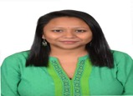

|  |  |  |  |
| --- | --- | --- | --- |
| **ACADEMIC PROFILE** | | | |
| M.A. Social Work in Dalit and Tribal Action | **Tata Institute of Social Sciences, Mumbai** | **6.8 (CGPA)** | **2015-17** |
| Graduation | K.L.E Law College, Bangalore. | 44.1% | 2009-13 |
| Class XII | Don Bosco College, Tura. | 66% | 2007-09 |
| Class X | Sherwood School, Tura. | 47.6% | 2004- 07 |

### CREDIT BASED COURSES (CBCS)

|  |  |
| --- | --- |
| **SUBJECT NAME** | **MARKS OBTAINED (CGPA)** |
| Perspectives On Urban Spaces | 5.8 |
| Global Public Health | 5.5 |
| Caste, State and Politics in South Asia | 7.8 |
| Crime, Culture and Media | 7.0 |

# RESEARCH:

**Topic**

Ramification of Hinduism of the age old matriarchal society of Koch tribe of Garo hills in Meghalaya.

|  |  |
| --- | --- |
| **WORK**  **EXPERIENCE**  **Centre for Financial**  **Accountability**  **(April – December 2017)**  **Human Rights Law Network**  **(Jan-Present 2018)** | * I have researched on the Indo -Bangladesh Friendship Project, The Rampal Project. * Published a booklet consisting of all the environmental, social, health and livelihood issue it will create. * Organizing and coordinating workshops on various issues, viz, environmental hazards, legal awareness and financial accountability of banks. * Reaching out to the community affected by installation of Rampal Project and documenting it. * Documenting reports on the impact of hazards on community. * Making a report on the investments of Exim Bank India and the environmental and livelihood issues people has faced due to it also he human rights law if any they have violated. * Networking with various other organizations from the ground and coordinating workshops with them. * Did various field research reproductive violations cases, for example: on a case where a woman had to deliver a baby in the fields where she was rejected of any Medical assistance from a district hospital. * Did research on cases where almost 599 women went through a uterus removal due to two-district doctor’s fraudulence. * Researching on various Reproductive Rights cases for women across India. * Drafting petitions. * Organized and coordinated a National Consultation on Women Rights. * Organizing and coordinating the North-East Consultation on various Human Rights issues. * Coordinating with all the state units of HRLN in northeast. * Writing proposals. |

#### FIELD WORK EXPERIENCES:

|  |  |
| --- | --- |
| SRUTI  (Nov 20-Dec 20 2016)  DHAATRI  (AUG 24-SEPT 24 2016)    CRY  (MAY 23-JUN 23 2016) | * Attended a national consultation on, “ Panchayat Raj, Social Movements and Democracy”. * Attended a seminar on, “Bhumi Adhikar Adolan” on completion of 10 yrs of FRI. * Made a report on DMIC which included the legal status of the DMIC, SPVs and Industrial development and impact of it on society and environment. * Studied civil as well as criminal cases relating to adivasi women. * Interviewed adivasi women on the problems they have been facing due to legal proceedings as well as gender biases in Gram Sabha and Gram Panchayat. * Held meetings with Gram Sabha as well as Gram Panchayat and advocating them on women rights and child rights. * Made a report on the whole work done and submitted to the organisation to put forward to the sub collector who is going to propose it as state proposal. * Transcript success story of APR which is funded by CRY. * Documentation on APR journey. * Interviewed people involved in the journey of APR. * Interviewed the women workers in the processing unit of GOONJ related to |

|  |  |
| --- | --- |
| GOON | * Wrote blogs for “taboo ki train” for NJPC. * Interviewed people in public spaces regarding taboos on periods they have faced or heard for NJPC website. * Made a report on the whole work done and submitted to the organisation. * Worked with street children ageing from 4 yrs to 20 yrs old. * Taught the children according to their age groups various subjects. * Home visits for various purposes. * Went to Govt Schools for their school admissions. * Conducted community mobilisation the send the children to study under RTE. * Conducted health activities according to age groups in the form of group work. * Conducted legal awareness seminar for the children as well as families. * Conducted a play with the children on social issues. * Conducted separate group discussion with boys and girls on adolescent issues. * Conducted a workshop along with ‘mobile crushers’. * Made a report on the whole work done and submitted to the organisation for follow ups. * Worked with children ageing from 11 yrs to 18 yrs . * The children were in Class 6 according to their mental age. * Conducted various games and activities for them. * Helped the class teacher in taking classes. * Observed each student and wrote a report on them to further help them. * Made a report on the whole work done and submitted to the organisation. * I was placed under the Roopantar Project of CYDA. * I was working with adolescents girls in the community. * Conducted seminars for adolescent girls on adolescent issues and problems they face. * Conducted life skills with a special focus on reproductive health, gender and menstrual hygiene for girls. |
| GOONJ  (MAY 02-MAY 18 2016) |
| SAALAM BAALAK  TRUST  (JULY 2015-MAR 2016) |
|  |
|  |
| KAMYANI SCHOOL FOR  MENTALLY HADICAPPED  (FEB 2015 –APR 2015) |
|  |
|  |
|  |
| CYDA  (AUG 2014- APR 2015) |
|  |

#### VOLUNTEER WORK:

Human Rights Education

Workshop

Cyber security Summit

* Was a volunteer and participated in 2nd day Human Rights Education Workshop by South Asia Coordinating Council (SACC) of International association for religious Freedom.
* Was a volunteer and participated in 2 day conference on Cyber Security Summit 3rd edition in Bangalore.

Mediation Centre, Bangalore.

* Was a volunteer in a 1 day seminar in Mediation and Arbitration organized by Bangalore Mediation Centre.

#### WORK EXPERIENCE:

#### INTERNSHIP:

|  |  |
| --- | --- |
| **NHRC,DELHI (JULY 2013)** | * **Submitted a report on the necessity of Human Rights as a subject in school and college level.** * **Attended seminars held by Joint Secretary, Senior Research Officers and Investigation Officers at Human Rights Office.** * **Visited an NGO, Bal Sahyog through NHRC.** * **Visited the Investigation Dept of NHRC and saw how it works and learned it how it provides aid to people.** * **Visited the Legal dept and learned how complaints are taken and moved forward to help.** |
| **CHAMBERS OF** | * **Assisted in drafting in civil cases.** |
| **SHEKHAR NANAVATY** | * **Went to various court visits.** |
| **(FEB 2013-MAR2013)** | * **Legal research on various cases.** |
|  |  |
| **CHAMBERS OF L.B RAI** |  |
| **AND ASSOCIATES** |  |
| **(JAN 2013)** | * **Legal research on various cases.** |
|  | * **Assisted in the proceedings of trial court.** |
|  | * **Assisted the team in various civil cases.** |
| **CHAMBERS OF KNH** |  |
| **CHANDRA AND** | * **Assisted the team in various civil and criminal cases.** |
| **ASSOCIATES** | * **Legal research on various ongoing cases.** |
| **(JULY 2011)** | * **Visited the courts.** |
|  |  |
| **IMPULSE NGO** | * **Researched on child labour cases.** * **Audio transcription on Women Leadership Programme.** * **Provided legal advice on illegal adoption case under “Impulse-case-info- centre”** |
| **NETWORK** |
| **(JULY 2010)** |
|  |

#### POSITIONS OF RESPONSIBILITY:

**CGPC Representative 2016-17**

**Students Social Forum Member 2009-13**

Tata Institute of Social Sciences

K.L.E Law College, Bangalore

**OTHER ACHIEVEMENTS**

* Won various dance competition.
* Won State level youngest child artist prize for theatres.
* Won various debates.

#### OTHER DETAILS:

|  |  |
| --- | --- |
| **LANGUAGES KNOWN** | Hindi, English, Bengali, Assamese, Garo, Nepali. |
| **SKILLS** | * **Specialised Skills-** Atlas Ti, SPSS, Research, Documentation, Casework, Group work, Community Organisation and Advocacy. * **Computer Skills:** MS Word**,** MS Excel, MS Power point**.** * **Soft skills:** Advocacy, Communication, Observation, Listening. |
| **INTEREST** | * Research, Documentation and Reading. * Dance, Sports and Cooking. |

##### I, hereby declare all the information given above is true.

