**Shubham Kumar Mishra**

**K**

**E-mail: skmishra1394@gmail.com**

**Phone: 8574230497, 7985572033 (MOB)**

**OBJECTIVE:**

I believe in looking forward to challenges which will enable me to exert myself to reach my    
potential. I hope to work in an environment which endorses teamwork and asks for optimum utilization of my knowledge and understanding of development. I seek opportunities which promote my overall growth and progress along with that of the organization.  

**Educational Qualification**

|  |  |  |  |
| --- | --- | --- | --- |
| **COURSE** | **INSTITUTE** | **YEAR** | **PERCENTAGE** |
| **MSW** | M.N.N.I.T, Allahabad | 2017 | 80 % |
| **Bachelor in Glob. and dev. Studies**  **INTERMEDIATE** | Allahabad University  Army School, Allahabad | 2015  2011 | 72 %  70 % |
| **HIGHSCHOOL** | Army School,  Allahabad | 2009 | 89 % |
|  |  |  |  |

**PROJECT EXPERIENCES**

* UNNAT BHARAT ABHIYAN, ; under this initiative of Government of India MNNIT has adopted few villages in its vicinity. Field work in these villages was a requirement of my Masters degree curriculum. Here I ran an awareness campaign regarding health and hygiene.
* Worked as a Co-ordinator at SWARA NGO. Here I worked for the empowerment of women in village, through social entrepreneurship.
* Training in CSR at Indo gulf fertilizers. Here I worked upon the following projects :-

1. Community Need Assessment of the talevand village.
2. Impact Assessment of the Toilet Project led by the Indogulf in Mangauli village.
3. Need assessment of the women training centre in Matthepur village, Jagdishpur.

* Internship from Manav Vikas Aivum Kalyan sansthan.
* Working as a Programme-coordinator in Pahal Samajik sanstha, Allahabad

**SKILLS**

* Knowledge of PRA ( Participatory Rural Appraisal ) techniques and Community Organisation..
* Knowledge of Social work.
* Knowledge of Organizational Behaviour.
* Technical knowledge of MS Office.
* C++ , HTML and SPSS
* Excellent Interpersonal and communication skills.
* Fluent in English and Hindi languages.

**STRENGTH**

* Discipline in personal and professional life.
* Confident and friendly personality.
* Inquisitive to learn anything that is new to me.
* Team ethics.
* Organizing and planning skills.

**HOBBIES**

* Volleyball.
* Reading.
* Travelling.

**Extra-Curricular Activities**

* Mr Freshers PG 2015, M.N.N.IT , Allahabad.
* Organised a workshop on **‘The Role of Educational Institution in Cleaning of River Ganga’** in 2014, University Of Allahabad.
* Organised a workshop on ‘Social Issues and technology in October 2016, M.N.N.I.T.
* Participated in **Swachha Bharat Campaign** organised in **M.N.N.I.T**.
* Organised SWAGAT 2016 fresher function at M.N.N.I.T.
* Organised street shows in Allahabad for awareness about various social issues like Eve teasing, Gender discrimination, Child labour etc.

I hereby declare that the information provided here are true to the best of my knowledge.

Place: Allahabad 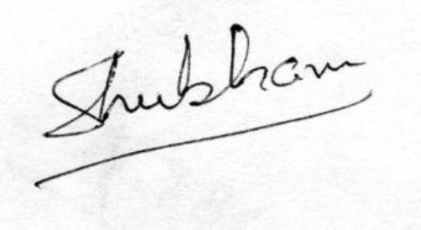

Date : 20th August 2018