**SHWETA GAUTAM** 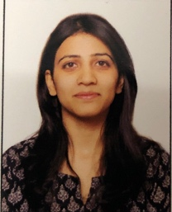

PERSONAL DETAILS :

**E-mail ID :** gautams1711@gmail.com

**Phone :** 9971418915

**Address :** 4/2 MULTISTOREY FLATS ,OPPOSITE UPSC

SHAHJAHAN ROAD

110011

**EDUCATION :**

**2018-2019 :** POST GRADUATION DIPLOMA

ENVIRONMENTAL LAW AND POLICY

WWF ( DISTANCE COURSE)

**2017-2019 :** M.A. ENVIRONMENTAL STUDIES

DEPARTMENT OF ENVIRONMENTAL STUDIES

DELHI UNIVERSITY

NEW DELHI

**2010 – 2013** : Bsc. PHYSICAL SCIENCES (75%)

AGRA COLLEGE

DR. B.R. AMBEDKAR UNIVERSITY

**2009** : 12TH , MAHARISHI PATANJALI VIDYAMANDIR (76%)

ALLAHABAD

**2007**: 10TH , ST. JOSEPH CO-ED SCHOOL (80%)

BHOPAL

**OTHERS :**

* Actively participated in National Workshop on Emerging Pollution Challenges on Earth Ecosystem , NEW DELHI
* Actively participated in International Conference on Adapting Environmental Laws for Effective Climate Response , NEW DELHI